[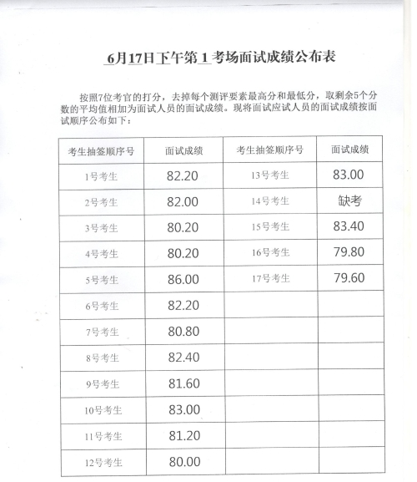](http://www.whzzb.gov.cn/picture/0/ac39c1a6f4aa4e7790a94b036d0d05ae.jpg)

[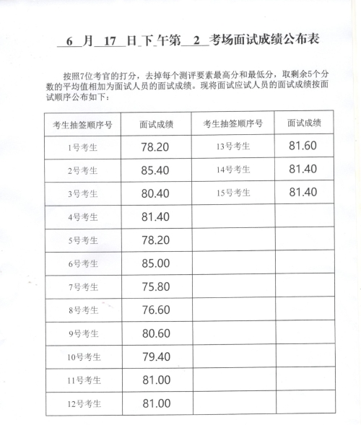](http://www.whzzb.gov.cn/picture/0/08084b44c46942e0ac6a2ac1f279a478.jpg)

[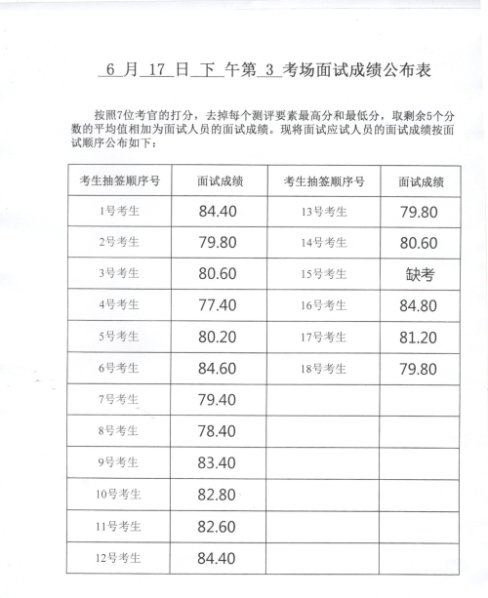](http://www.whzzb.gov.cn/picture/0/3520e8532db44bb4b4583c0d26f99ce1.jpg)

[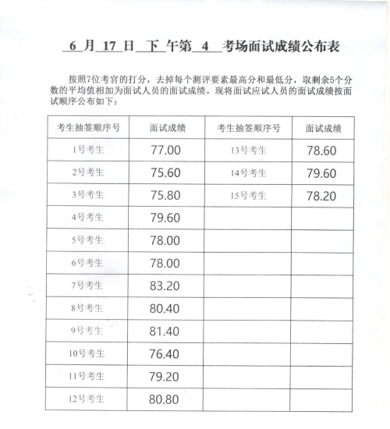](http://www.whzzb.gov.cn/picture/0/82a9754e3bfc4de6aae0bc18afbc9cb3.jpg)

